***HCL Commerce V9.1***

***CyberSource Integration Developer Guide***

**Draft - Version 1.0**

**March 26, 2023**



**Document Source**

|  |  |  |  |
| --- | --- | --- | --- |
| Version # | Date | Version Description and Summary of changes | Editor |
| 1.0 | August 12, 2021 | Draft- First version of review | Mahesh |

# **Introduction**

This document is about the integration of Razorpay Payment with HCL Commerce where Customer can place the order using Razorpay Payment.

# **About the Code**

Once you have approval to integrate the Razorpay Payment. HCL provide the Plugin_Configuration folder. This folder contains following projects-

1. Dataload
2. HCLRazorpayPaymentPlugin
3. Rest
4. WC
5. WebSphereCommerceServerExtensionsLogic

# **Prerequisites**

1. Razorpay Key.
2. Razorpay Secret Key

Follow the below URL to generate the key & secret

https://dashboard.razorpay.com/app/website-app-settings/api-keys

1. Update the Razorpay.sql file from \Dataload\sql\Razorpay.sql

* storeId
* langId
* Razorpay_api_key
* Razorpay_secret_key

# **Integration Steps**

1. Run the Dataload

* Run acp policy file RazorpayAccessControlPolicies.xml from \Dataload\acpload\ RazorpayAccessControlPolicies.xml
* Run Razorpay.sql fiel from Dataload\sql\Razorpay.sql

1. Copy the jar file from WC/lib/… files into your {HCL_Commerce_Workspace}\WC/lib folder.

**Note**: there are 8 jar files.

1. Payment Plugin Configuration
   1. Copy HCLRazorpayPaymentPlugin folder from WC/xml/config/payments/ppc/plugins to your {HCL_Commerce_Workspace}\WC/xml/config/payments/ppc/plugins folder.
   2. Copy **RZ-PAY** folder from WC/xml/config/payments/edp/groups/default/ZRazorpayOnlineConfiguration to your {HCL_Commerce_Workspace}/WC/xml/config/payments/edp/groups/default/ folder.
   3. Merge the PaymentSystemPluginMapping.xml from WC/xml/config/payments/ppc/plugins/PaymentSystemPluginMapping.xml to your {HCL_Commerce_Workspace}/WC/xml/config/payments/ppc/plugins/PaymentSystemPluginMapping.xml. Below code need to merge-

|  |
| --- |
| <!-- Razorpay Start -->  <PaymentSystemName name=*"RazorPayPaymentSystem"*>  <Mapping paymentConfigurationId=*"default"* pluginName=*"HCLRazorpayPaymentPlugin"*>  <Keyword name=*"account"* mask=*"*"* plain=*"-5"* searchable=*"true"*/>  </Mapping>  </PaymentSystemName> <!-- RazorpayEnd --> |

* 1. Merge the PaymentMethodConfigurations.xml from WC/xml/config/payments/edp/groups/default/PaymentMethodConfigurations.xml to your {HCL_Commerce_Workspace}/WC/xml/config/payments/edp/groups/default/PaymentMethodConfigurations.xml. Below code need to merge-

|  |
| --- |
| <!-- Razorpay Start -->  <PaymentMethodConfiguration humanEditable=*"true"*  maximumAmount=*"Unbounded"* minimumAmount=*"0"* name=*"RZ-PAY"*  partiallyConsumable=*"false"* paymentSystemName=*"RazorPayPaymentSystem"*  priority=*"LOW"* refundAllowed=*"true"* systemEditable=*"true"*/>  <!-- Razorpay End --> |

* 1. Merge the PaymentMappings.xml from WC/xml/config/payments/edp/groups/default/PaymentMappings.xml to your {HCL_Commerce_Workspace}/WC/xml/config/payments/edp/groups/default/PaymentMappings.xml. Below code need to merge-

|  |
| --- |
| <!-- Razorpay Start -->  <Mapping paymentActionRule=*"Early Deposit"*  paymentConfiguration=*"RZ-PAY"* paymentMethod=*"RZ-PAY"*/> <!-- Razorpay End --> |

1. Copy the WebSphereCommerceServerExtensionsLogic changes

Copy the below files/folder to your {HCL_Commerce_Workspace}/ WebSphereCommerceServerExtensionsLogic.

|  |
| --- |
| 1. WebSphereCommerceServerExtensionsLogic/src/com/hcl/commerce/payments/razorpay/commands 2. WebSphereCommerceServerExtensionsLogic/src/com/hcl/commerce/payments/razorpay/handler |

1. Merge the Rest changes

Merge the resources-ext.properties from Plugin_Configuration Rest/WebContent/WEB-INF/config/resources-ext.properties to your {HCL_Commerce_Workspace}/Rest/WebContent/WEB-INF/config/resources-ext.properties. Below code need to merge.

|  |
| --- |
| com.hcl.commerce.payments.razorpay.handler.HCLRazorPayRestHandler |

1. Copy HCLRazorpayPaymentPlugin to your {HCL_Commerce_Workspace}.

* Go to RAD
* Click on File > Import
* Select EJB > EJB JAR file into Workspace and click on Next.

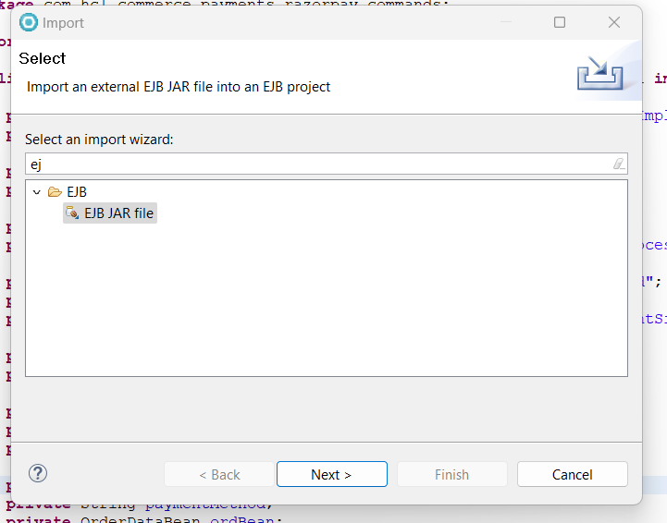

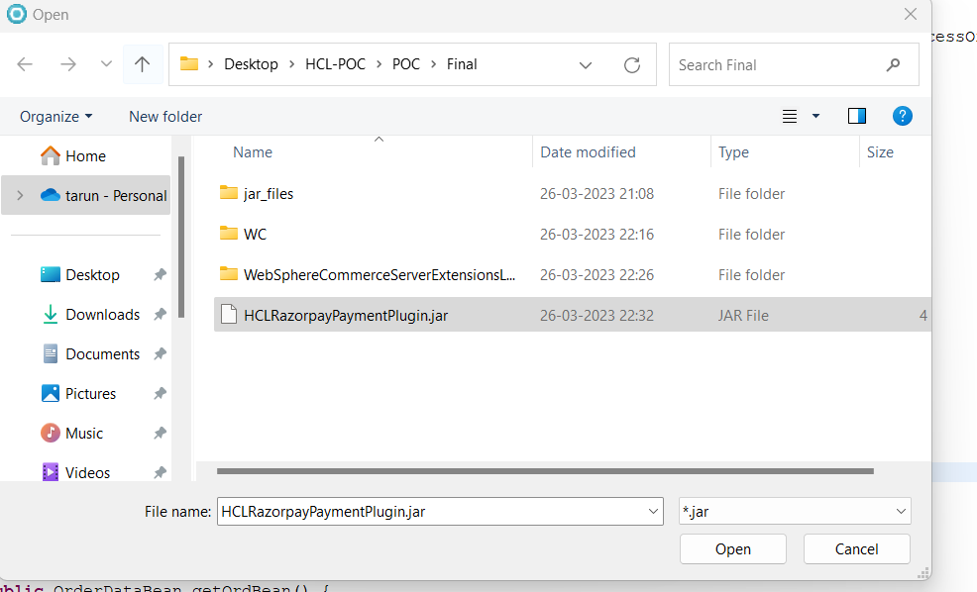

* Select root directory click on Browse. Select the HCLRazorpayPaymentPlugin. Project select the Checkbox and click Finish.

1. Dependency & Deployment
   1. Add HCLRazorpayPaymentPlugin folder to WebSphereCommerceServerExtensionsLogic build path.

* Right click on the WebSphereCommerceServerExtensionsLogic.
* Select the Build Path > Configure Build Path.
* Click on Projects and Add the HCLRazorpayPaymentPlugin folder.

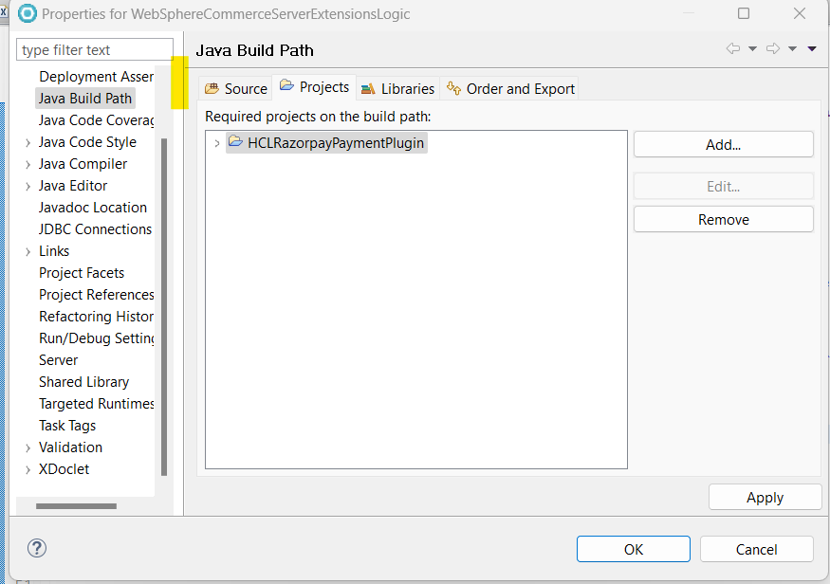

* 1. Deploy the HCLRazorpayPaymentPlugin in local toolkit
* Open the RAD
* Select Enterprise Explorer
* Open WC > HCLCommerceServer
* application.xml file will open
* Click on Manage Utility Jars
* Ear Module Assembly > Click on Add
* Click on Add and Select Directive Type as Project.
* Click on Next, Select HCLRazorpayPaymentPlugin and Finish.

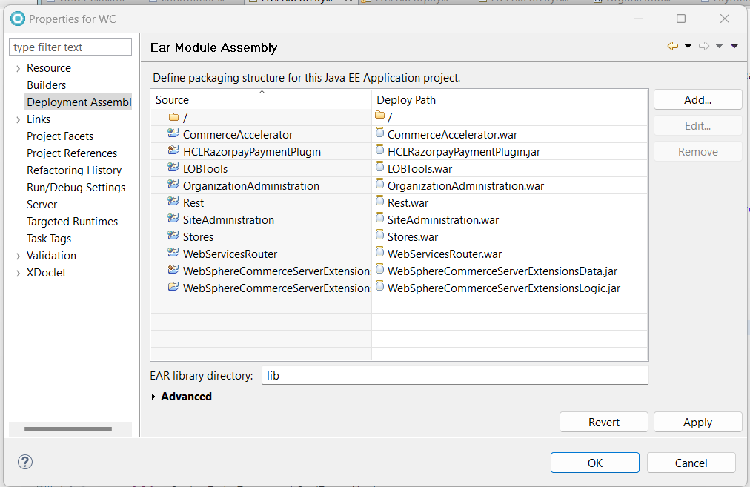

7.3 Restart WebSphere Commerce Server.